Louis Peters
Graag verzoek ik u deze lijst zo volledig mogelijk in te vullen Al uw gegevens vallen onder het beroepsgeheim
Persoonlijke gegevens
Naam …………………………………………………………………………………………………………………………………………………
Voorletter(s) …………………………… Geslacht m/v Roepnaam …………………………..
Geboortedatum……………………………………………………………………………………………………………………………………
Adres……………………………………………………………………………………………………………………………………………………..
Postcode …………………………………………………………………………………………………………………………………………… Woonplaats…………………………………………………………………………………………………………………………………………
Telefoon privé…………………………………………………………………………………………………………………………………….
Telefoon werk……………………………………………………………………………………………………………………………………..
Mobiele telefoonnummer…………………………………………………………………………………………………………………..
Emailadres…………………………………………………………………………………………………………………………………………….
BSN nummer…………………………………………………………………………………………………………………………………………
Gegevens verwijzer
Naam huisarts …………………………………………………………………………………………………………………………………………………………………
Adres: huisarts(en)praktijk ……………………………………………………………………………………………………………………………………………………………….
Telefoon…………………………………………………………………………………………………
Vindt u het goed als er overleg met de huisarts is over uw behandeling? Ja / Nee

(1)

Verzekeringsgegevens
Verzekeringsmaatschappij………………………………………………………………..

Polisnummer………………………………………………………………………………..

Lichamelijke klachten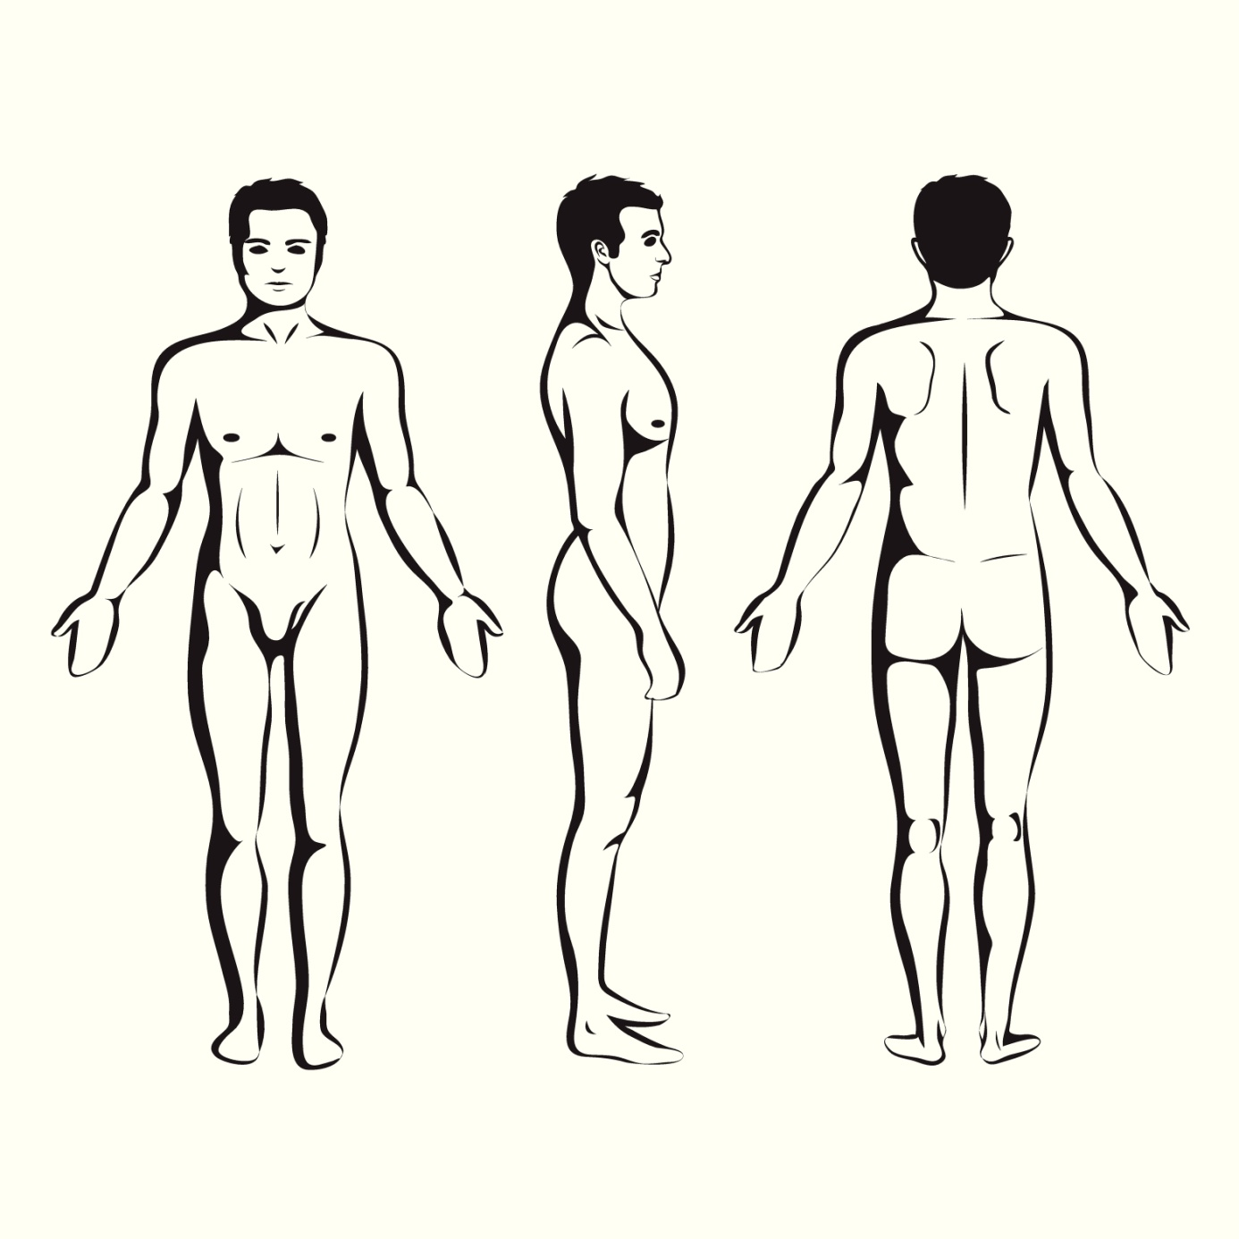
(2)

Wat zijn uw belangrijkste klachten?
…………………………………………………………………………………………………………………………………………………………………………………………………………………………………………………………………………………………………………………………………………………………………………………………………………………………………………………………………………………………………………………………………………………………………

Sinds wanneer heeft u deze klachten?
…………………………………………………………………………………………………………………………………………………………………………………………………………………………………………………………………………………………………………………………………………………………………………………………………………………………………………………………………………………………………………………………………………………………………………………………………………………………………………………………………………………………………………………………………………………………………………………………………………………………………………………………………………………………………………………………………………………………………………………………………………………………………………………………………………………………………………………………………………………………………………………
Kunt u aangeven hoe deze klachten zijn begonnem?
……………………………………………………………………………………………………………………………………………………………………………………………………………………………………………………………………………………………………………………………………………………………………………………………………………………………………………………………………………………………………………………………………………………………………………………………………………………………………………………………………………………………………………………………………………………………………………………………………………………………………………………………………………………………………………………………………………………………………………………………………………………………………………………………………………………………………………………………………………………………………………………………………………………………………………………………………………………………………………………………………………………
Verwachtingen
Kunt u zo concreet mogelijk aangeven wat u van mij verwacht en wat u wilt bereiken?
Opmerkingen
…………………………………………………………………………………………………………………………………………………………………………………………………………………………………………………………………………………………………………………………………………………………………………………………………………………………………………………………………………………………………………………………………………………………………………………………………………………………………………………………………………
(3)

Algemene gezondheid
Gebruikt u medicijnen? 0 Nee 0 Niet meer 0 Ja,

Opmerkingen ……………………………………………………………………………………………………………………………………………………………………………………………………………………………………………………………………………………………………………………………………………………………………………………………………………………………………………………………………………………………………..
Datum …………………………………………………….

Handtekening ………………………………………………………………………………………………………………………………………..……………………

(4)

